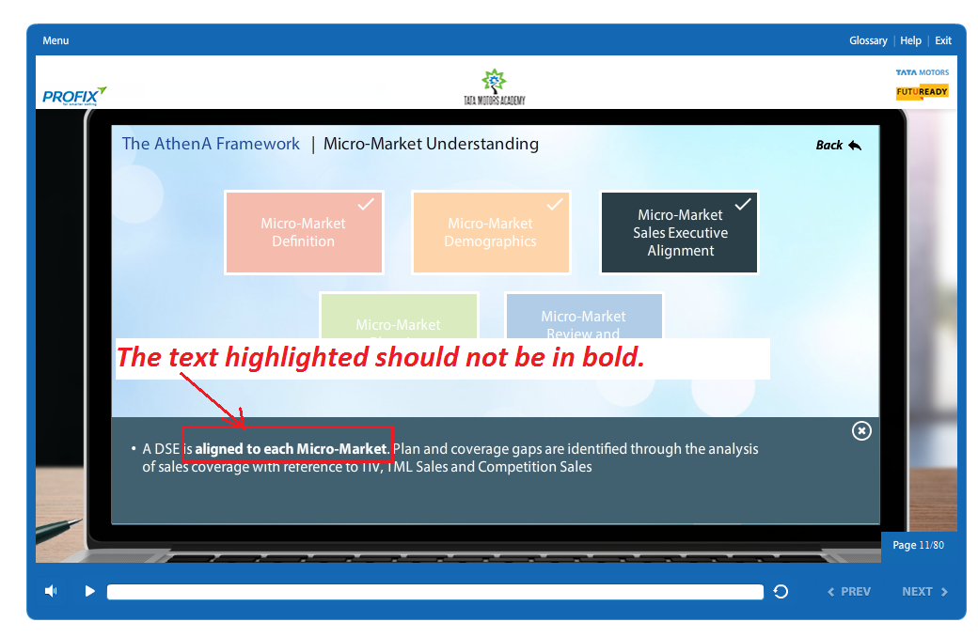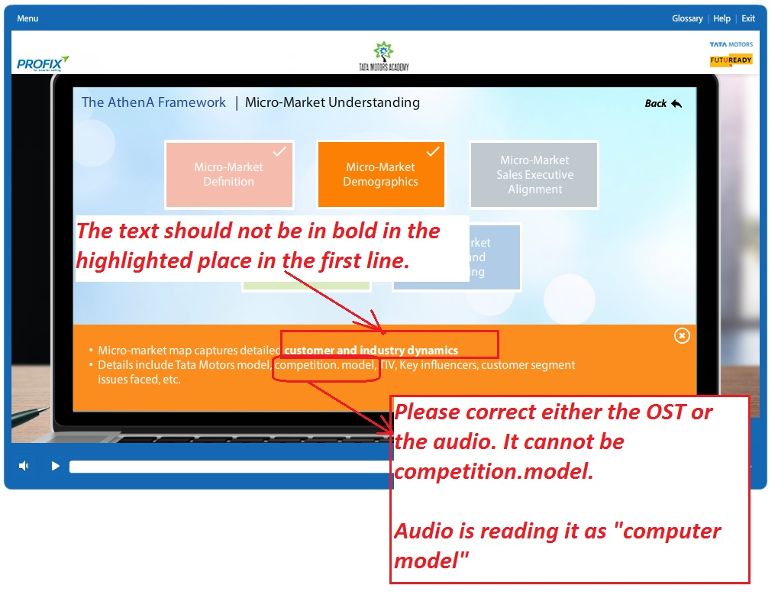

Don’t show the text in bold in the highlighted places below. Correct this on all popups of this slide.

